**Practical No.03**

**1]create database, collection and document.**

use school

db.student.insert([

{"RollNo":101,"Name":"abc","Gender":"Male","Age":20,"class":"TYIT"},

{"RollNo":102,"Name":"def","Gender":"female","Age":25,"class":"TYIT"},

{"RollNo":103,"Name":"ghi","Gender":"Male","Age":22,"class":"TYIT"},

{"RollNo":104,"Name":"jkl","Gender":"female","Age":23,"class":"TYIT"},

{"RollNo":105,"Name":"mno","Gender":"Male","Age":24,"class":"TYIT"},

{"RollNo":106,"Name":"pqr","Gender":"female","Age":25,"class":"TYIT"},

])

db.student.find()

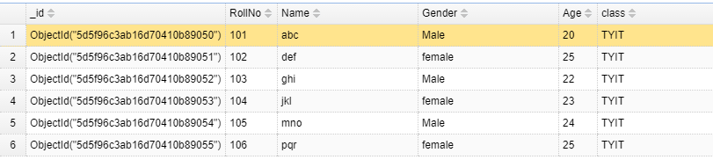

**A] Write a MongoDB query to use sum, avg, min and max expression.**

**1]sum-**

**Query:**

db.student.aggregate([{$group: { _id: "$Gender",Myresult:{$sum:1}}}])

**Output:**

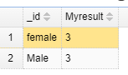

**2]avg-**

**Query:**

db.student.aggregate([{$group: { _id: "$Gender",AvgAge:{$avg: "$Age"}}}])

**Output:**

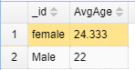

**3]min-**

**Query:**

db.student.aggregate([{$group: { _id: "$Gender",MinAge:{$min: "$Age"}}}])

**Output:**

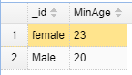

**4]max-**

**Query:**

db.student.aggregate([{$group: { _id: "$Gender",MaxAge:{$max: "$Age"}}}])

**Output:**

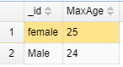

**B] Write a MongoDB query to use push and addToSet expression.**

**1]push:**

**Query:**

db.student.aggregate([{$group: { _id: "$Gender",Name:{$push:"$Name"}}}])

**Output:**

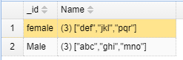

**2]addToSet:**

**Query:**

db.student.aggregate([{$group: { _id: "$Gender",AddToSet:{$addToSet:"$Name"}}}])

**Output:**

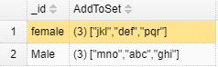

**C] Write a MongoDB query to use first and last expression.**

**1]first:**

**Query:**

db.student.aggregate([{$group: { _id: "$Gender",First:{$first:"$Name"}}}])

**Output:**

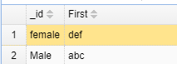

**2]last:**

**Query:**

db.student.aggregate([{$group: { _id: "$Gender",last:{$last:"$Name"}}}])

**Output:**

